Compiling a C++ Program in Microsoft Visual Studio 2010

Objective: After completing this experiment you will be able to:

- create an empty C++ project;
- generate a source file to hold a C++ program;
- compile (build) a C++ program;
- execute a C++ program;

Step 1: Open Visual Studio 2010. You should see a screen similar to the one shown
below. Now, select New Project, and continue to the next step.

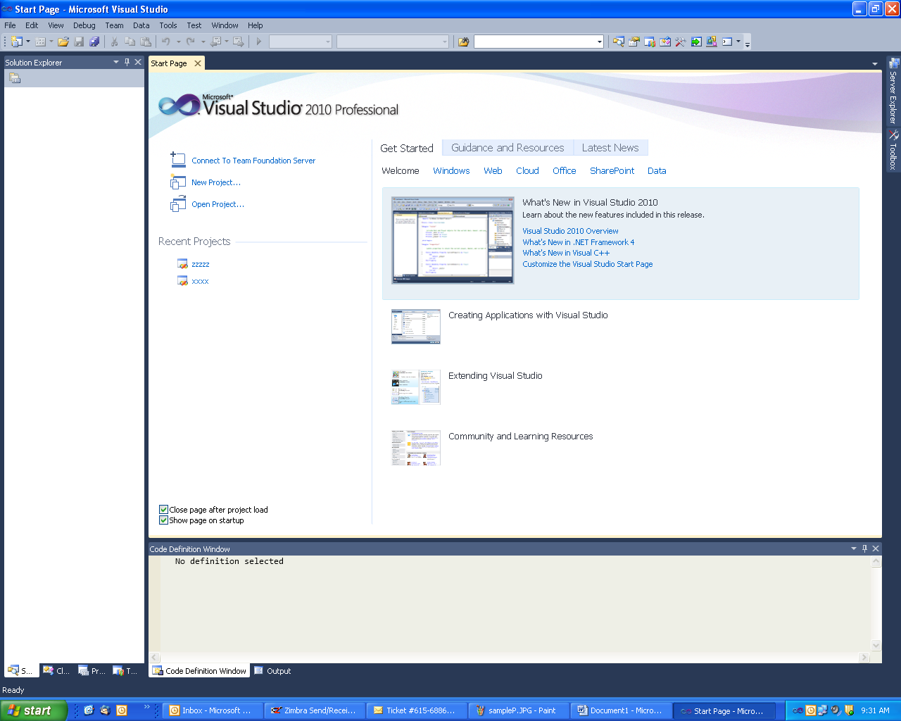

Step 2: Your screen should look similar to the one below. Perform the following
actions:
- Choose Visual C++ in the “Installed Templates” area;
- Choose Win32 Console Application in the middle section;
- Name the project “my_first_project”;
- Create a folder called “COP3014_Laboratory” by provide the location where the folder “COP3014_Laboratory” will reside.

Continue to the next step.

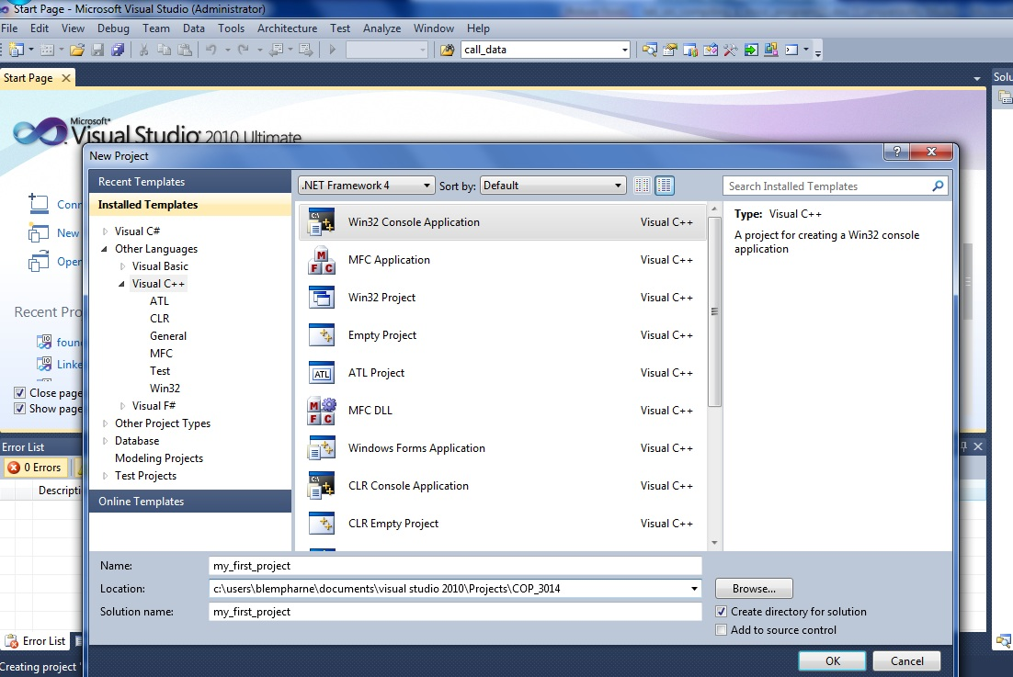

Step 3: Your screen should look similar to the screen shown below. Choose next, and
continue to the next step.

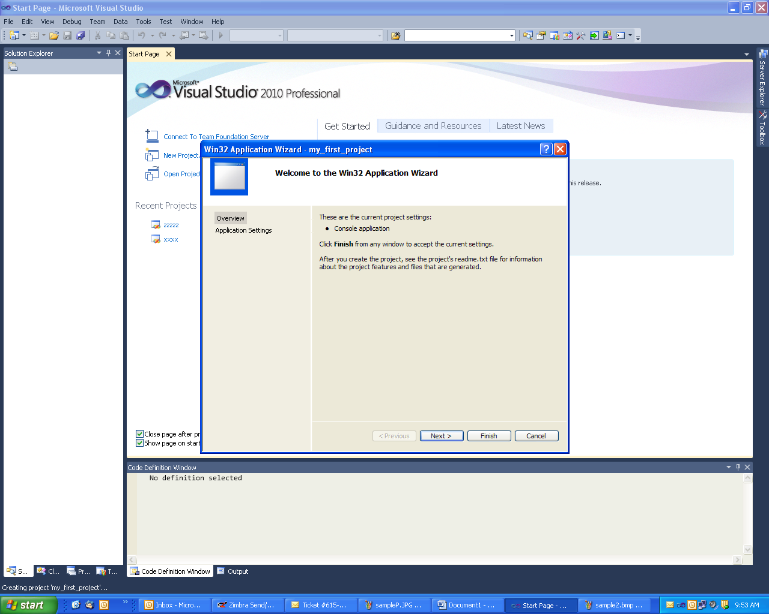

Step 4: Your screen should look similar to the screen shown below. Choose “empty
Project”. The Application type should be “console application”. Now select
Finish, and continue to the next step.

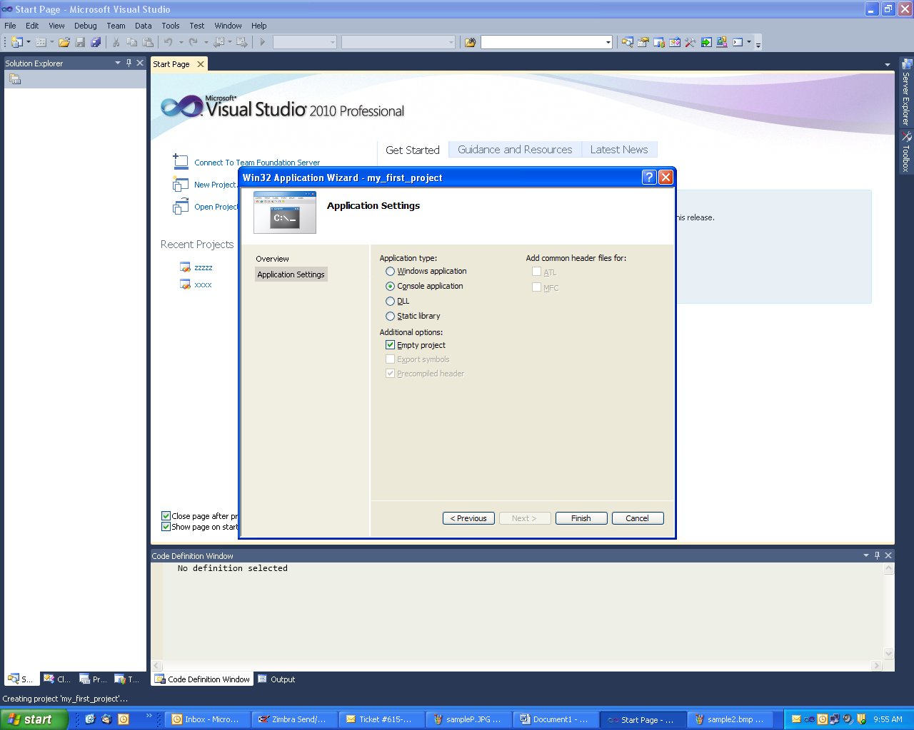

Step 5: Your screen should look similar to the blank screen shown below. Continue to the next step.

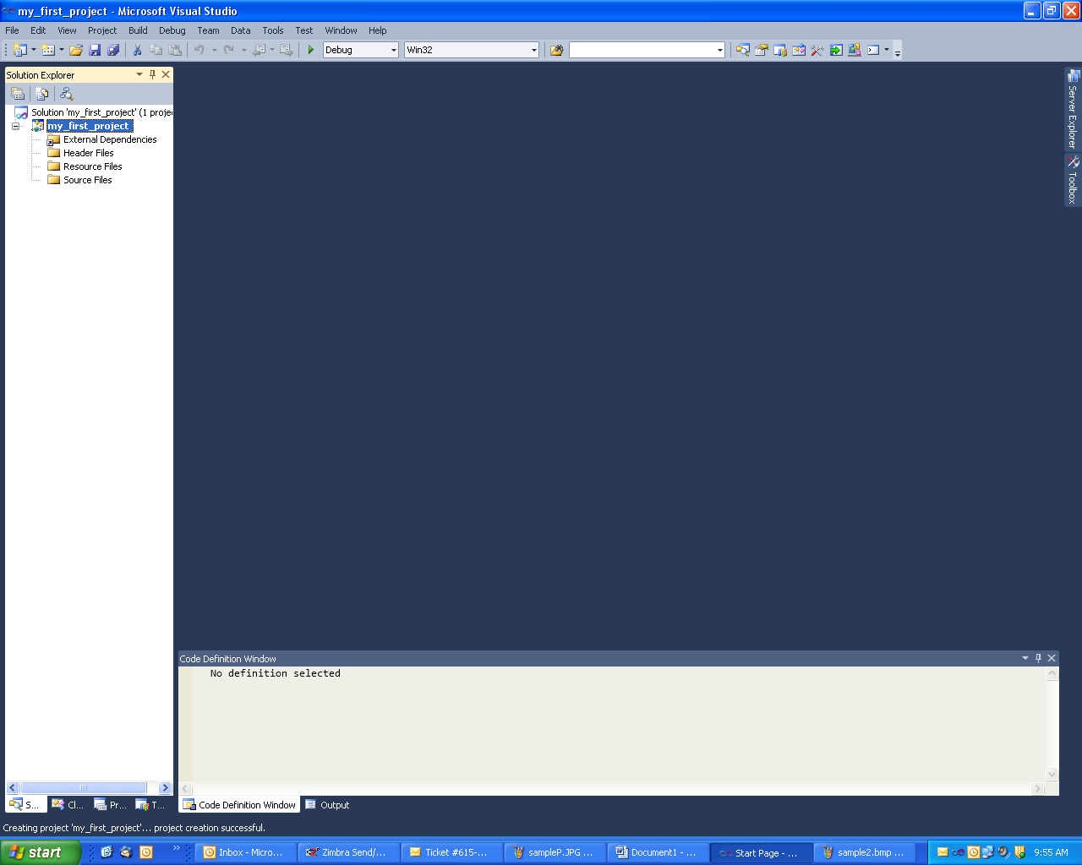

Step 6: Select the Project pull down menu, and choose “Add New Item”. Continue to
the next step.

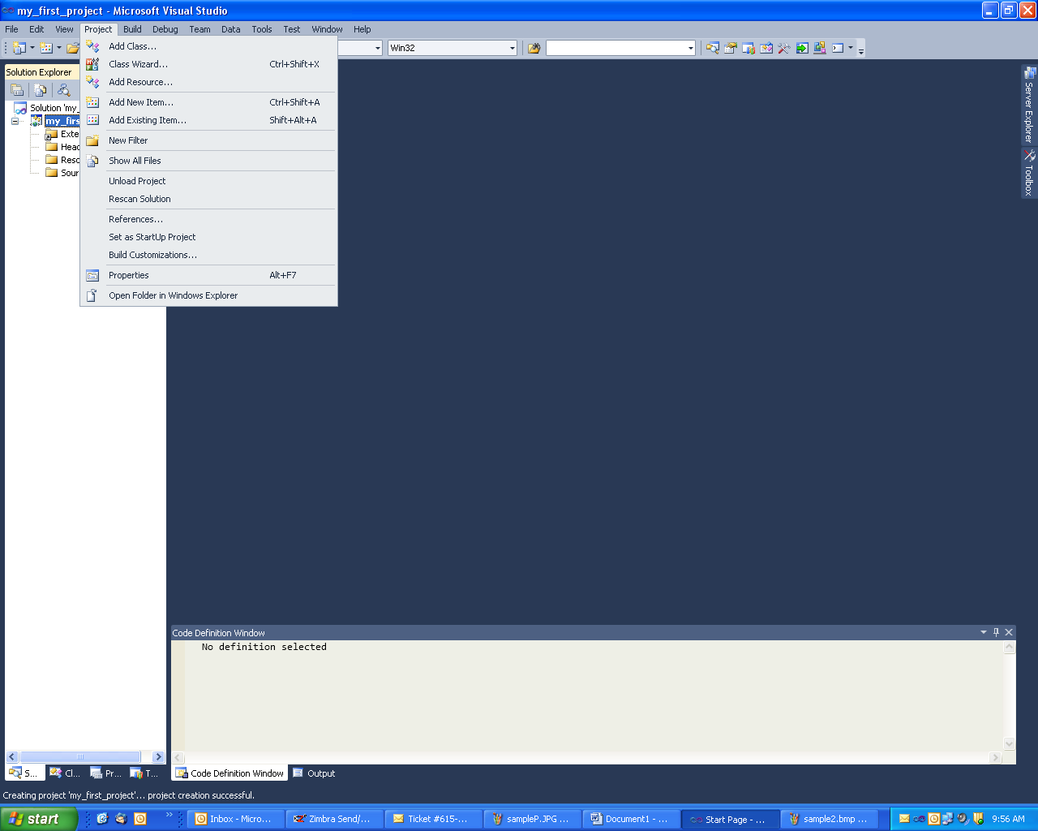

Step 7: Your screen should look similar to the one shown below. In the middle section
select “C++ File(.cpp)”. Name the source file “my_first_program” in the name
field at the bottom. The location field should already be set to the location of
your project. Choose Add, and continue to the next step.

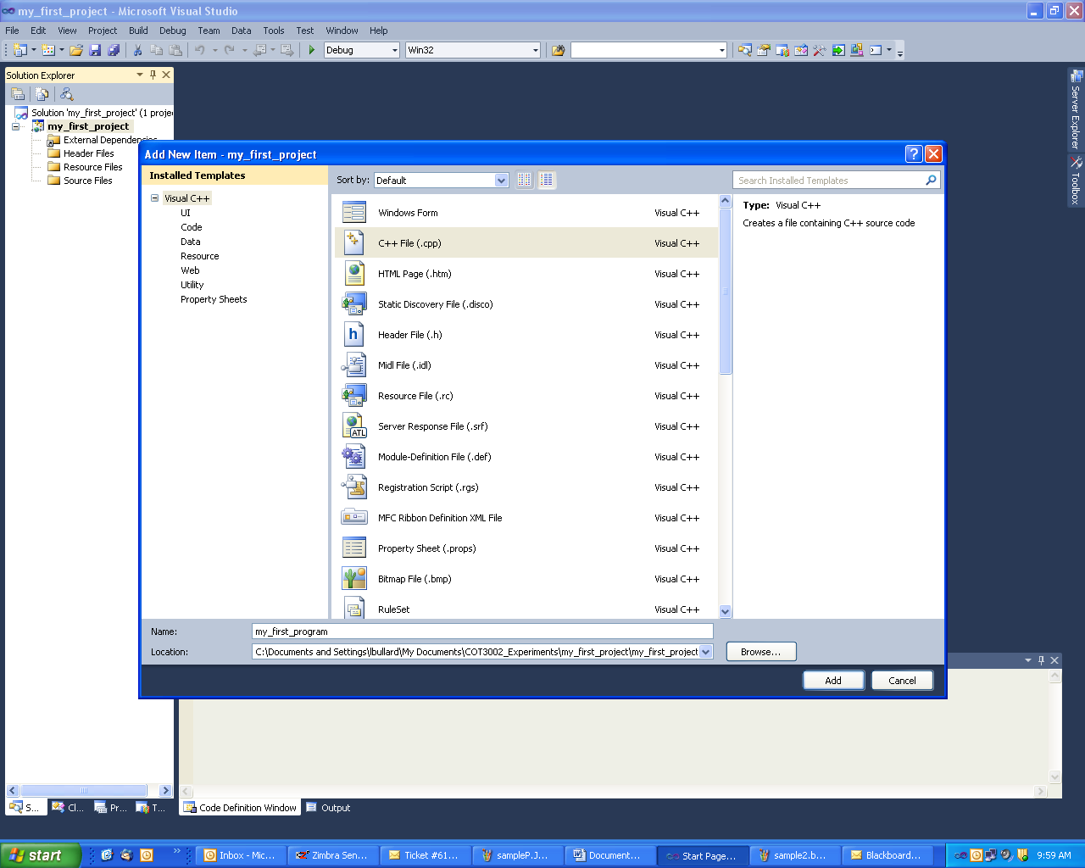

Step 8: Your screen should look similar to the one shown below. Continue to the next
step.

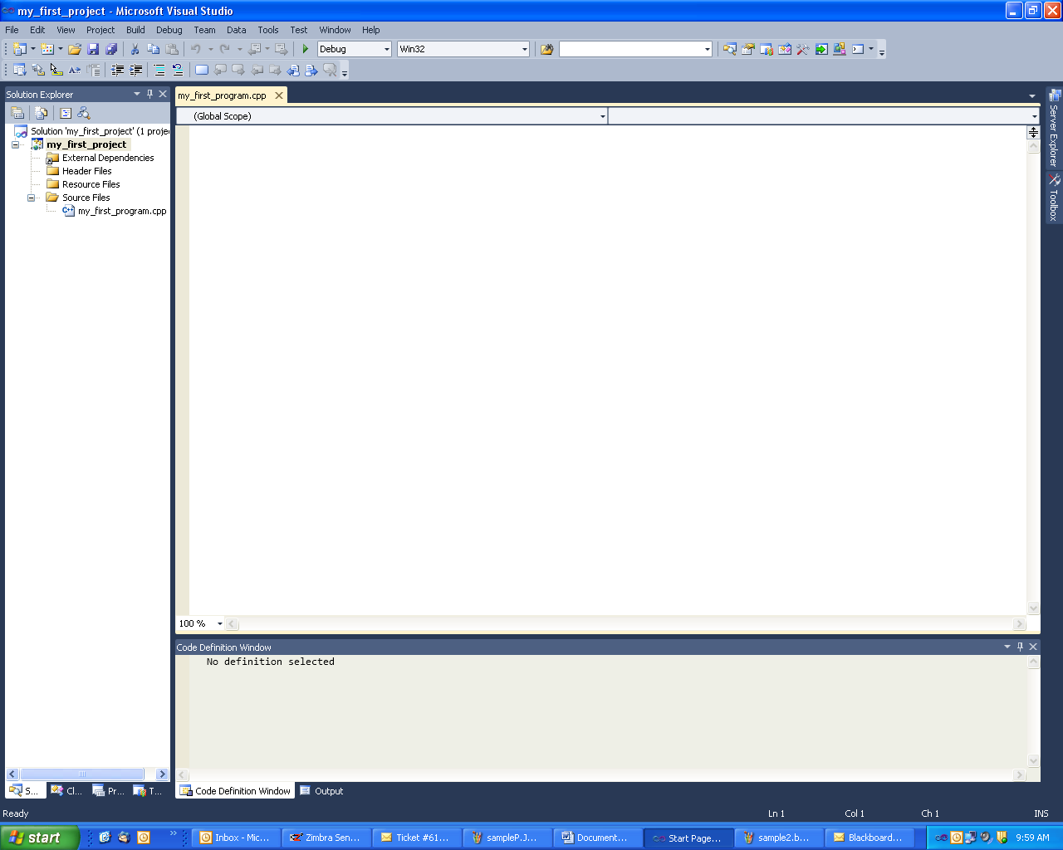

Step 9: Enter the C++ program shown below. Be careful or you will get errors when you
try to compile and execute the program. Pay close attention to the syntax.
If you enter the program correctly, it will compile without any errors. Continue
to the next step after you enter the program.

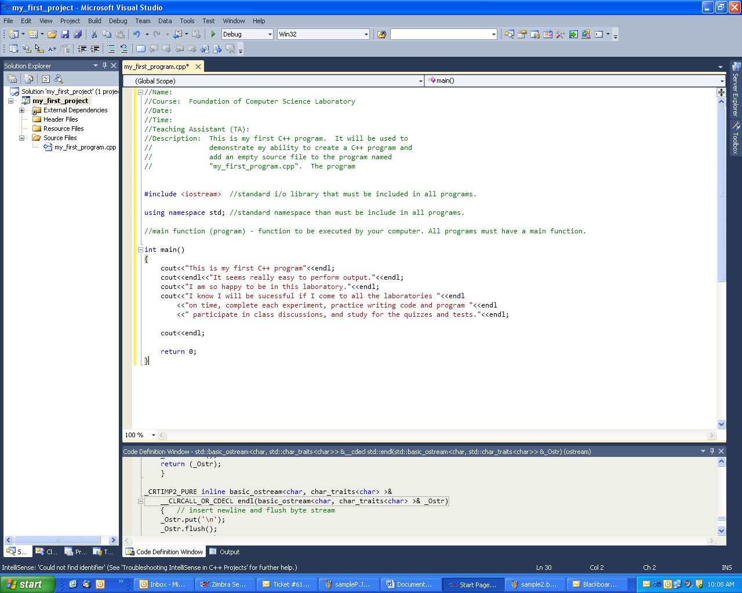

Step 10: Choose the Build pull down menu, and select Build Solution. During this step
the C++ compiler will compile your program. Continue to the next step.

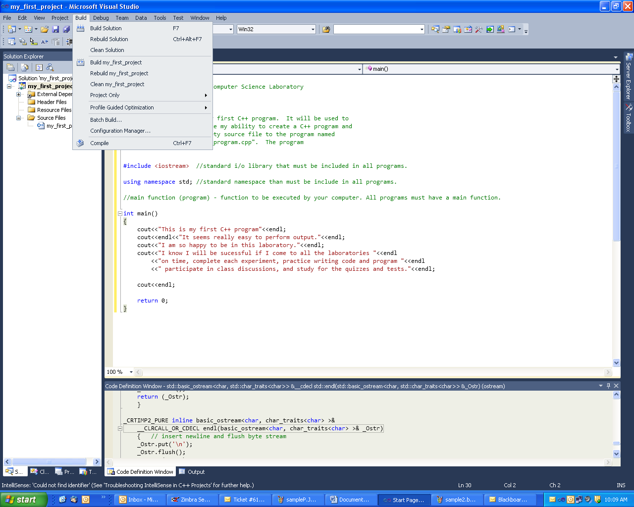

Step 11: Your screen should look like the one shown below. If you get any errors, try to
fix them. If you can’t, speak to your laboratory TA immediately.

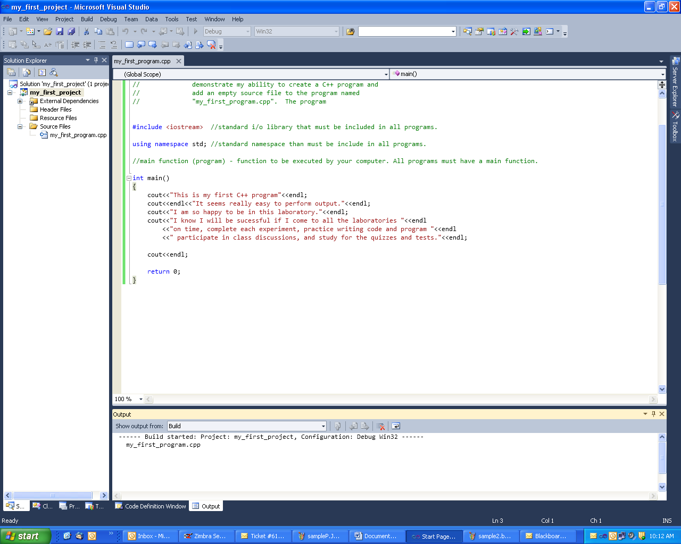

Step 12: Choose the Debug pull down menu, and select “Start Without Debugging”.
Your program should execute without any problems. If your program does not
execute, speak to your laboratory TA. Continue to the next step.

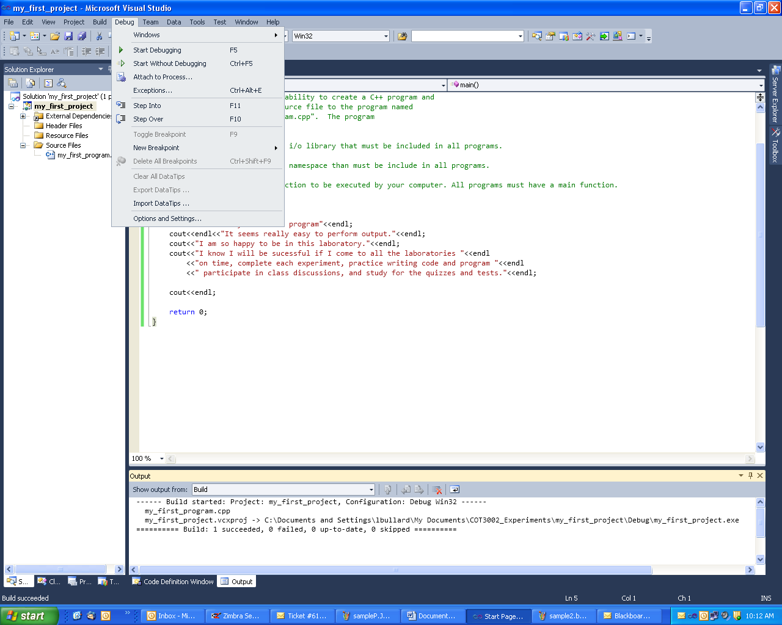

Important: If this is your first time using Visual Studios 2010, the black console window may appear to flash briefly then disappear. If this is the case you need to setup your Output to Console. To do this:
1. Go to “Project” then choose the last item: “my_first_project Properties…”
2. Choose the ‘+’ and open up Configuration Properties.
3. Choose the ‘+’ and open up Linker.
4. Choose System. This opens up a number of options on the right side.
5. Under SubSystem, go to right side of the pull down menu and choose:
Console (/SUBSYSTEM:CONSOLE)
6. Choose OK to save your changes. Then rebuild and run your program.

Step 13: Your screen should look like the screen shown below. The black screen shows
the output produced by your program. Continue to the next step.

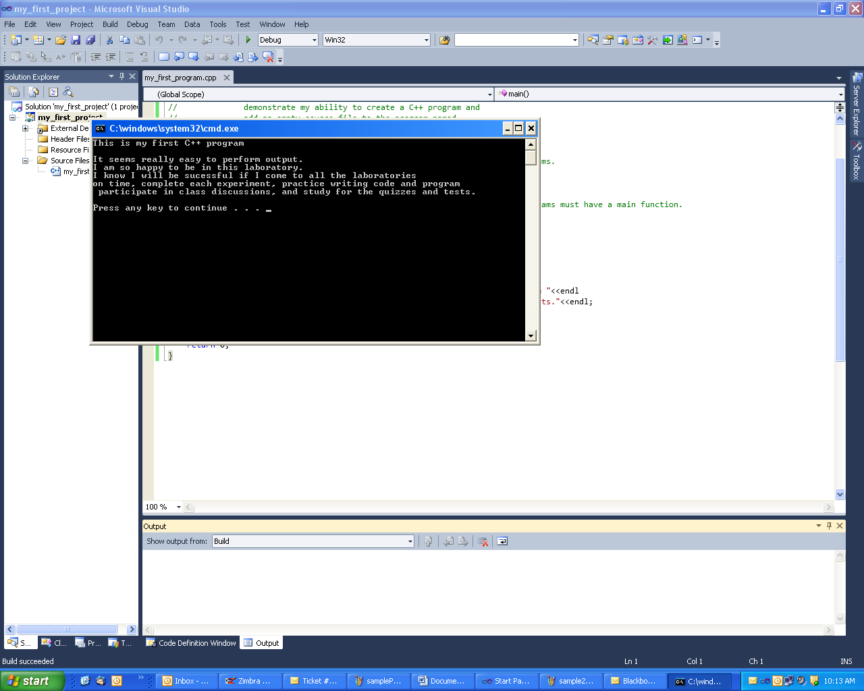

Step 14: Choose the File pull down menu, and select “Save All”. Continue to the next
step.

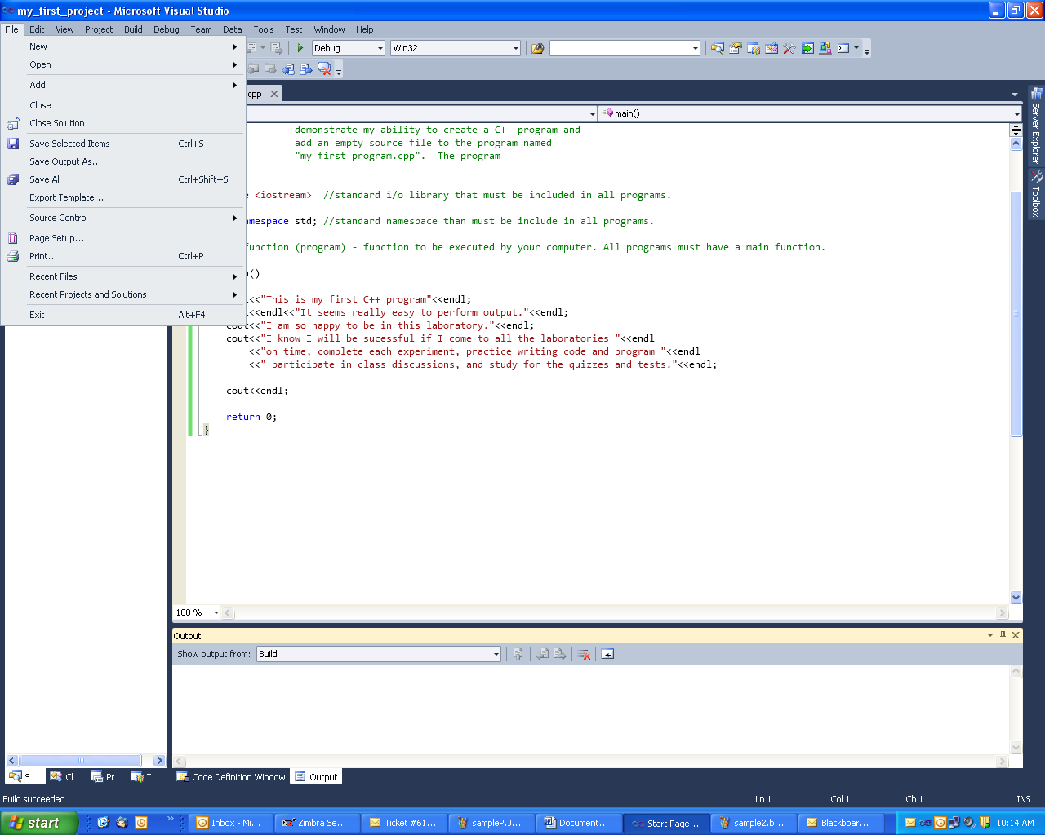

Step 15: Choose the File pull down menu, and select “Exit”. Continue to the next step.

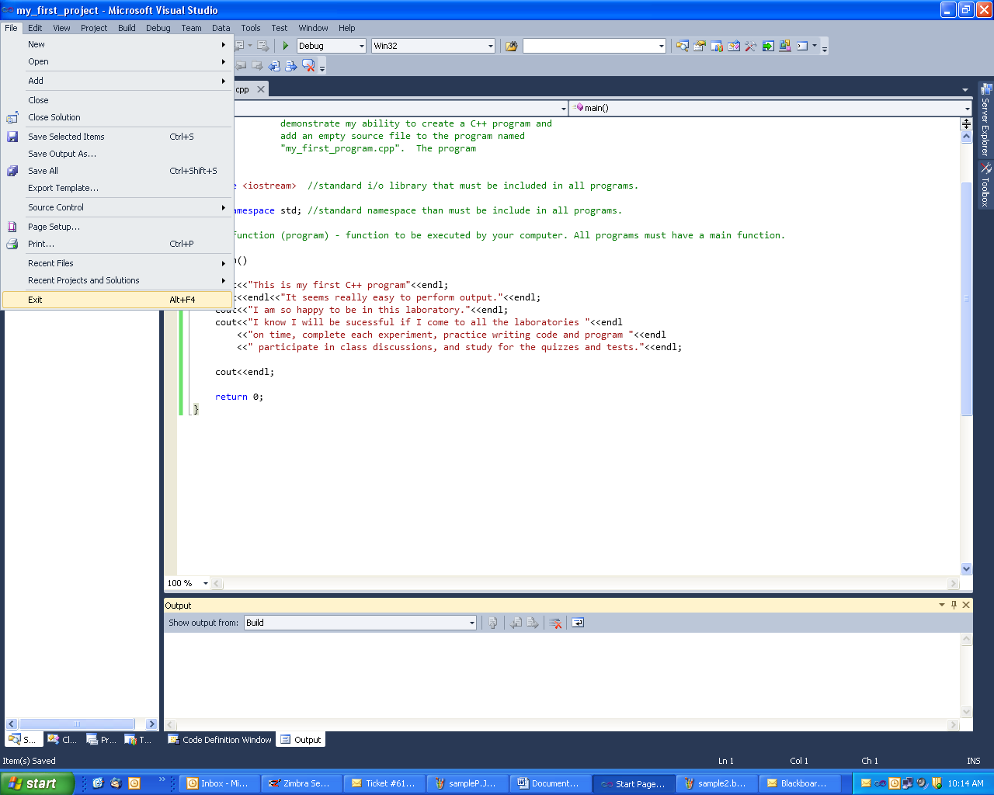

Step 16: You have complete your first experiment.

